 | Abstract title, left, 14-point bold, Century Gothic type  Jane Gold¹, Tom A. Silver¹, Laura Steel ²(10-point, Century Gothic)  ¹Affiliation 1(left, 10-point, Times New Roman, Italic)  ²Affiliation 2 (left, 10-point, Times New Roman, Italic)  E-mail: author@world.com

Abstracts must be written in English and the preferred length of the abstract is about 300 words. The name of the presenting author should appear first in the list of authors. The e-mail address of the presenting author is recommended.
The text should be single-spaced, and each paragraph indented as indicated here. The text should be justified. Use 10-point Century Gothic typeface, and Symbol font if necessary. Your abstract is limited to one page of A4 paper. The margins must be 2.0 cm on all sides for A4 paper. Black and white or gray scale images and drawings (no color) may be embedded into the text as desired. If images are included, please make sure that the resolution is suitably high. Please do not put in the abstract more than one figure (see Figure 1). For best results, submit artworks in the actual size and do not resize it in the word processor. References in the text must be enclosed in square brackets [1].
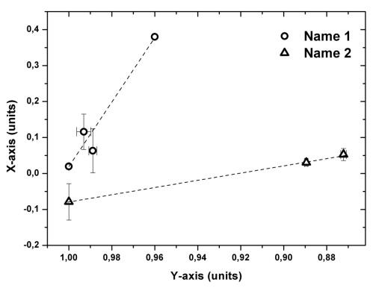
Figure 1. Figure name

Abstracts must be submitted in English, and all presentations must be made in English. Abstracts are subject to review [1,2].
Abstracts will be published exactly as submitted. Copy should be checked for accuracy and typographical problems prior to submission. Please do not convert your abstract into PDF file.
The abstracts should be uploaded in the ABSTRACTS section of the conference site (http://agchem2022.com/).
Funding acknowledgement (if applicable).
References:
[1] Reference reference reference reference reference reference reference reference
[2] Reference reference reference reference reference reference reference reference

